OXIDATION OF TUNGSTEN AND MOLYBDENUM: THE EFFECTS OF BOUNDARY LAYER TRANSPORT

S. Sharafat and N. M. Ghoniem

The University of California at Los Angeles (UCLA)
Los Angeles, CA. 90095-1597, USA

APEX STUDY GROUP MEETING

UCLA

February 15-17, 1999

PRESENTATION OUTLINE

- QUASI-EQUILIBRIUM OXIDATION OF W AND Mo.
- BOUNDARY LAYER TRANSPORT MODEL.
- TEMPERATURE LIMITS FOR W.
- TEMPERATURE LIMITS FOR Mo.

QUASI-EQUILIBRIUM TREATMENT OF HETEROGENEOUS REACTIONS

@ SURFACE IMPINGEMENT RATE OF OXYGEN:

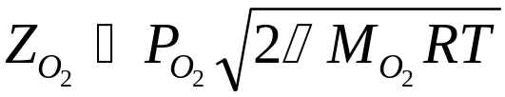
@ FOR OXYGEN MOLECULES AT A TEMPERATURE T*, THE EQUILIBRATED OXYGEN FLUX IS:

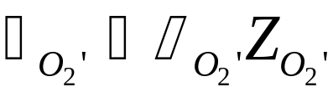
@ W AND Mo ARE DESCRIBED BY: 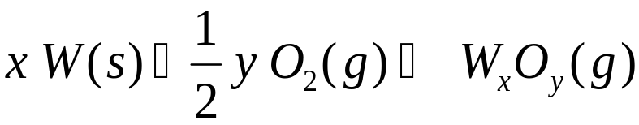
W AND Mo OXIDES

Tungsten |  | Molybdenum
Species | ΔHf_{298.15} (kcal/g.mole) | Species | ΔHf_{298.15} (kcal/g.mole) | ΔSf_{298.15} (cal/g.mole.K)
O(g) | 59.559 | O(g) | 61.3 | 16
W O(g) | 101.6 | Mo O(g) | 95 | 25.5
WO₂ (g) | 18.3 | MoO₂ (g) | 11.0 | 9.0
W O₃ (g) | -70.0 | Mo O₃ (g) | -80 | -15.5
W₂ O₆ (g) | -278.2 | Mo₂ O₆ (g) | -270 | -72
W₃O₈ (g) | -408.7 | Mo₃O₈ (g) | -400 | -118
W₃O₉ (g) | -483.6 | Mo₃O₉ (g) | -463 | -132
W₄O₁₂ (g) | -670.2 | Mo₄O₁₂ (g) | -640 | -190

QUASI-EQUILIBRIUM - KINETIC LIMITATION

@ SOLVE FOR :
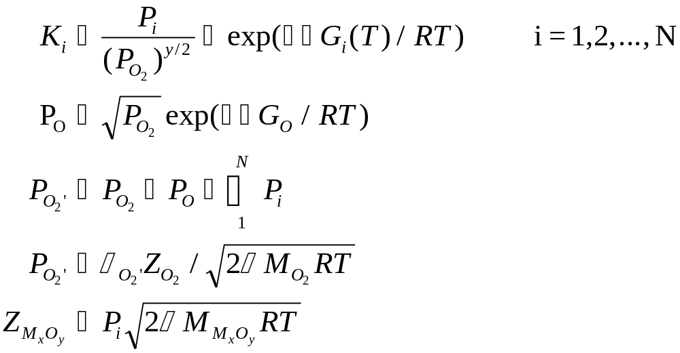
For W 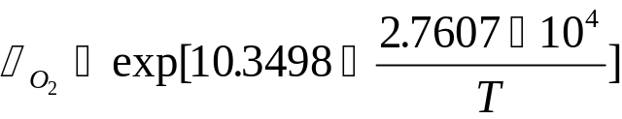 , T (ºK)

For Mo 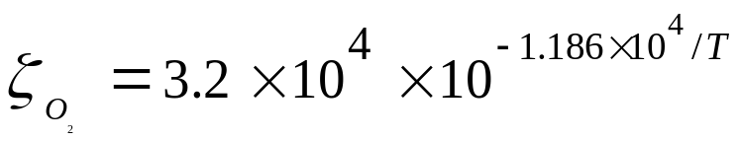, T(ºK)

EXPERIMENTAL DATA FOR W and Mo AT FIXED Z
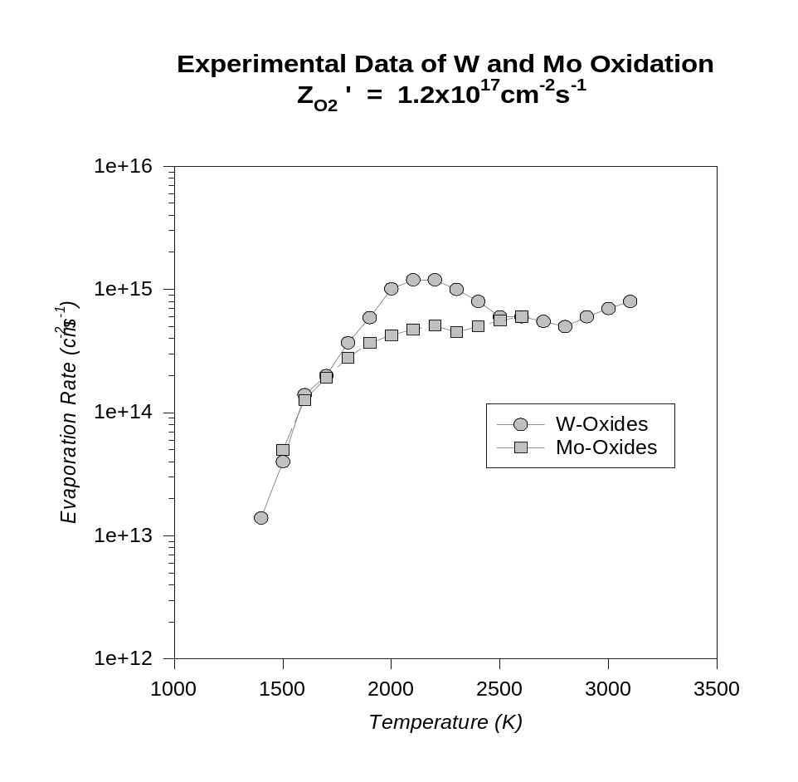@ TOTAL EVAPORATION RATE = 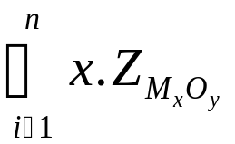
TOTAL EVAPORATION RATES OF W and Mo AT 1ppm O₂
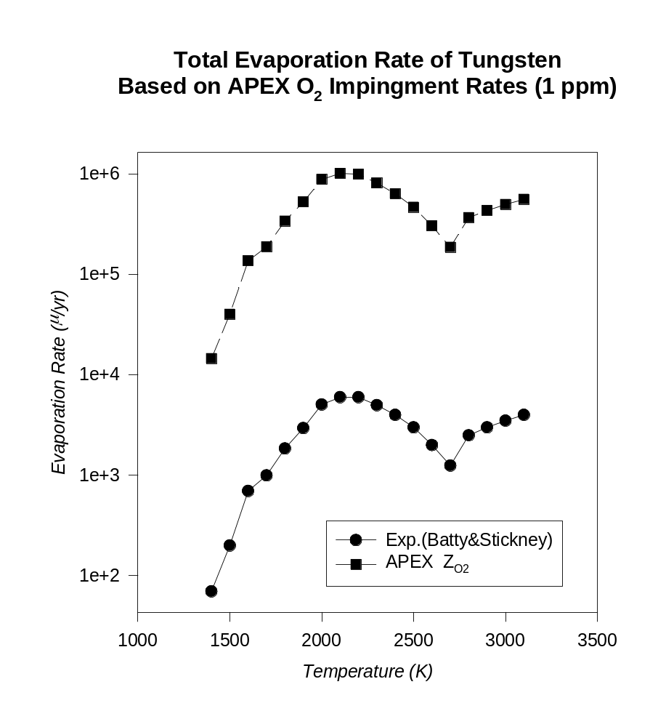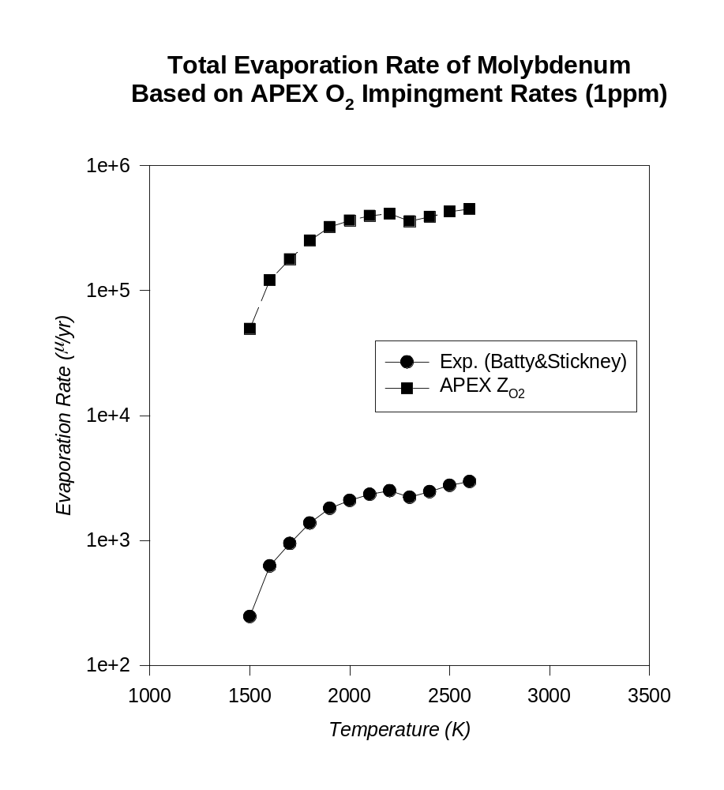@ TOTAL EVAPORATION RATE =
TOTAL EVAPORATION RATES OF W and Mo AT 1ppb O₂
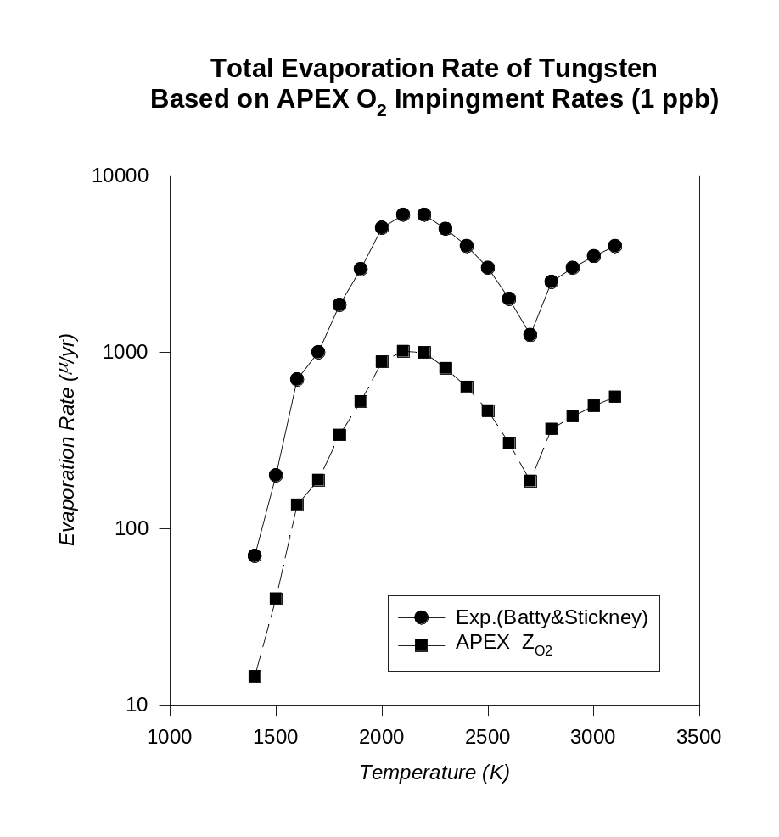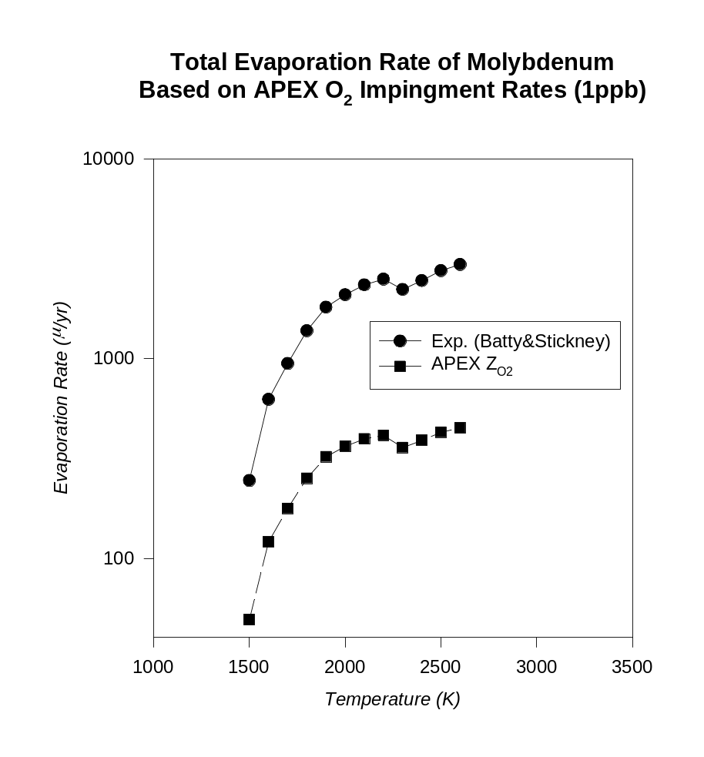
@ TOTAL EVAPORATION RATE =

BOUNDARY LAYER TRANSPORT MODEL

@@ SURFACE KINETIC RATE

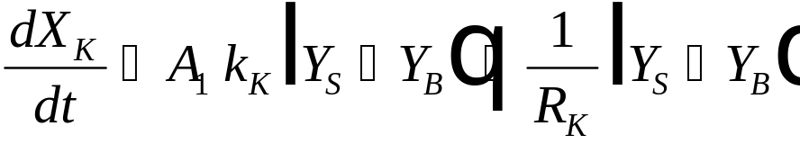
Y_{S}
Y_{B}
Y∞
@@ BOUNDARY DIFFUSION RATE

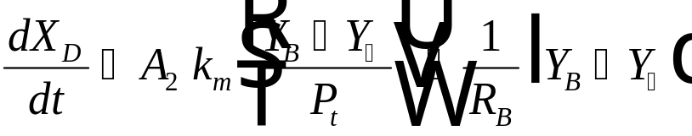

@@ SOLVE FOR 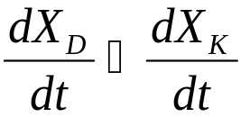 TO OBTAIN Y_{B}.

@@ FINAL EVAPORATION RATE: 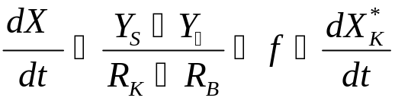
@@ WHERE (f) IS A BOUNDARY LAYER FACTOR, AND 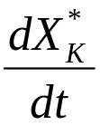IS THE KINETIC RATE WITHOUT THE BOUNDARY LAYER.

@@ THE BOUNDARY LAYER "RESISTANCE" IS GIVEN BY:

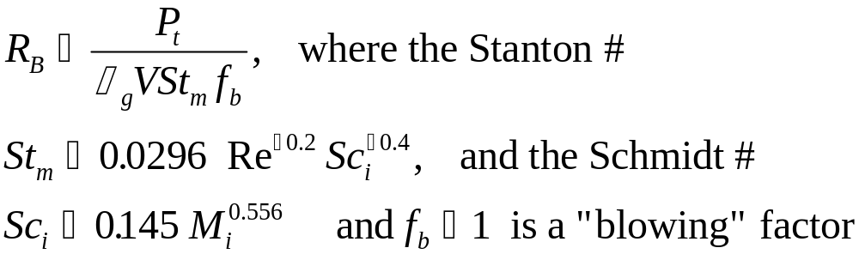

@@ AND THE KINETIC "RESISTANCE" IS GIVEN BY:

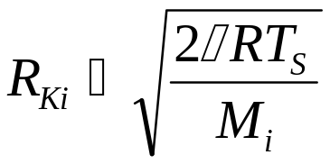

EFFECT OF BOUNDARY LAYER RESISTANCES
ON EVAPORATION RATES (1ppm O₂)
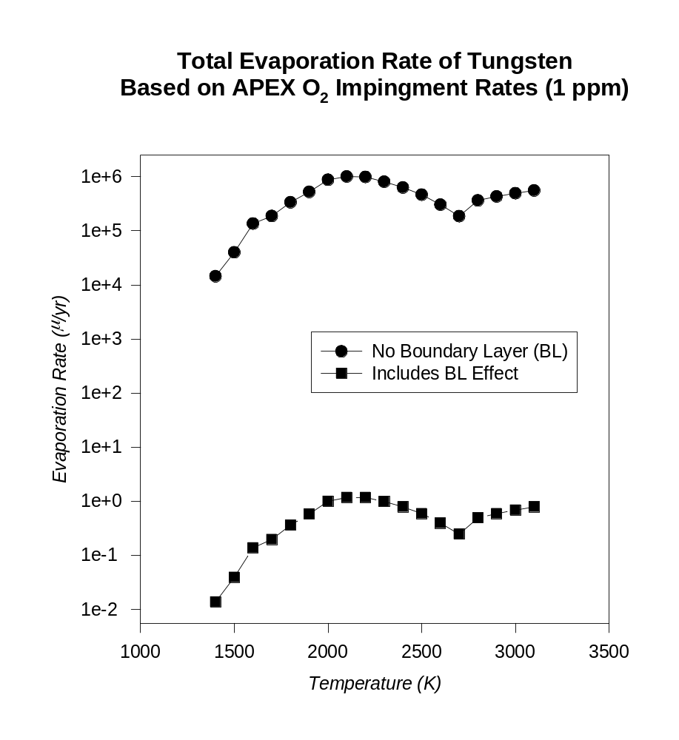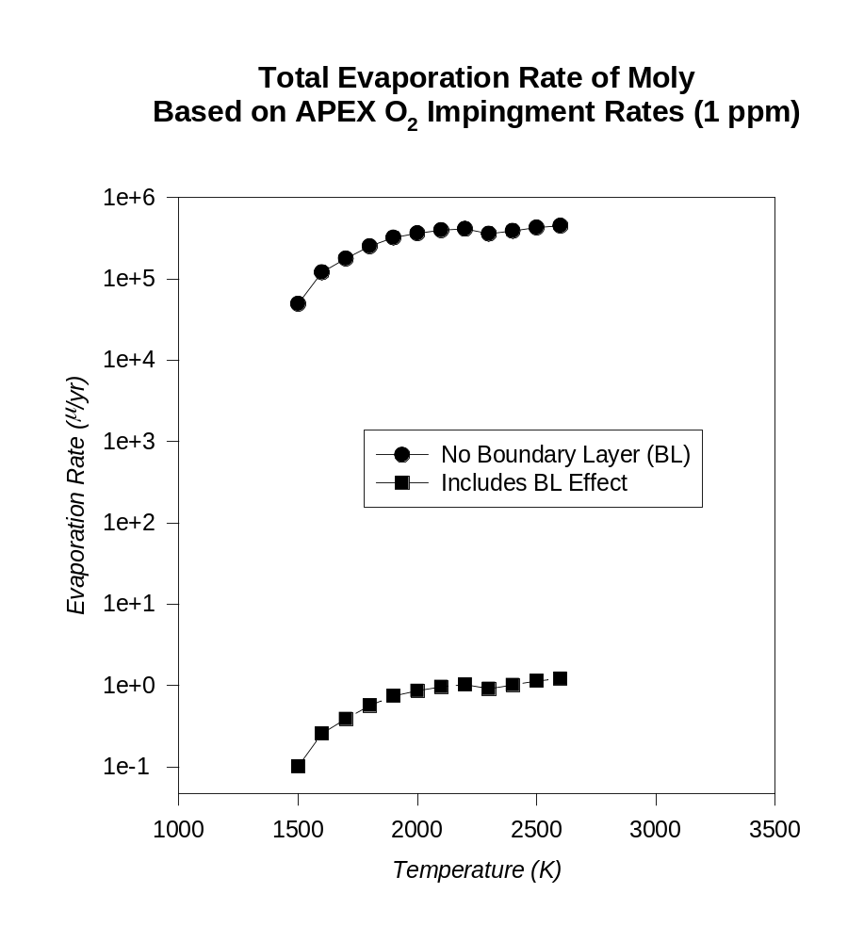
EVAPORATION RATES OF W and Mo INCLUDING
BOUNDARY LAYER RESISTANCES (1ppm & 1ppb O₂)
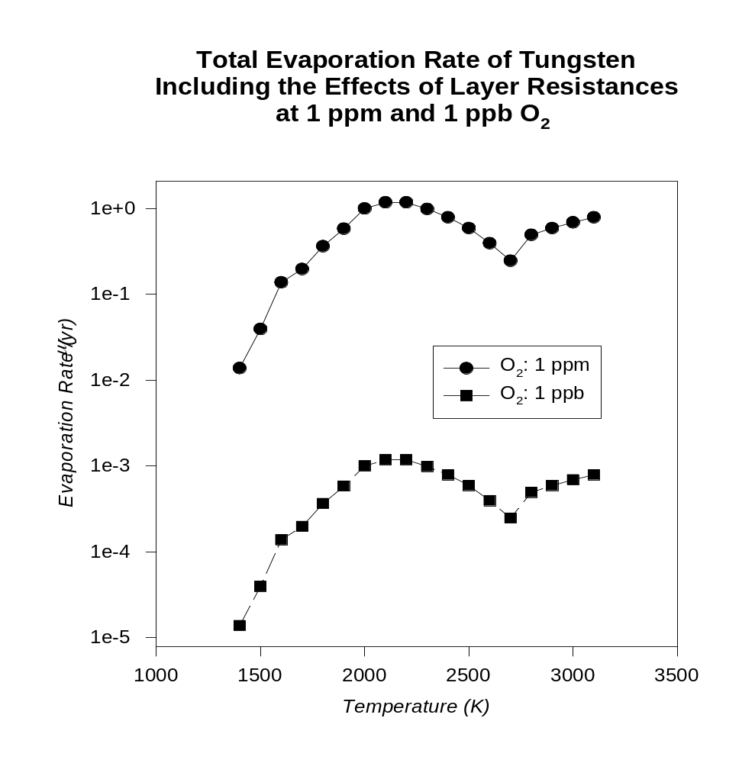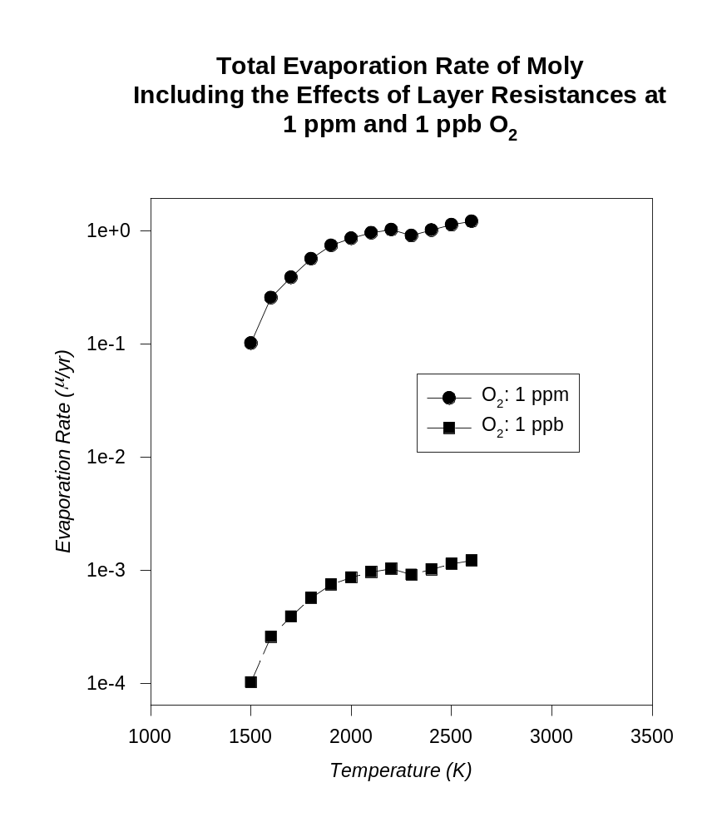
CONCLUSIONS
- BASED ON EXPERIMENTAL DATA, THE IMPINGMENT RATE
OF O₂ WAS ESTIMATED TO ESTIMATE STATIC EVAPORATION
RATES.

- THE BOUNDARY LAYER RESISTANCE TO OXIDE PRODUCT
TRANSPORT IS SIGNIFICANT AT THE HIGH HELIUM PRESSURES OF
THE APEX STUDY

- BASED ON THE BL-EFFECT THE EVAPORATION RATE IS ~0.1 μm/yr FOR Mo and ~0.01 μm/yr FOR W at 1 ppm O₂ AT 1500ºC.

- AT 2000ºC THE EVAPORATION RATE IS ~1O⁻³μm/yr FOR BOTH Mo and W at 1 ppb O₂.

- FOR AN OXIDATION RATE LIMIT OF 0.1 μm/yr THE OPERATING TEMPERATURE FOR Mo IS 1500ºC AND FOR W IT IS 1600ºC.

